App Server & Web server
Launch EC2 instance name as rani
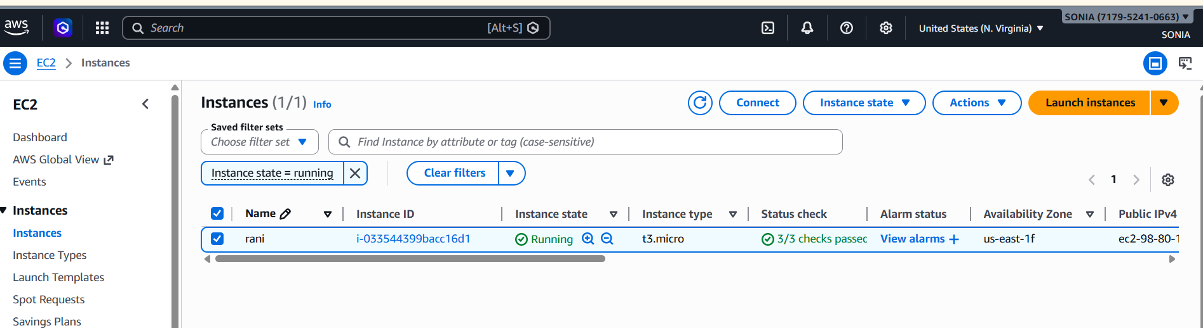

- ssh -i "rani.pem" ec2-user@ec2-98-80-103-155.compute-1.amazonaws.com
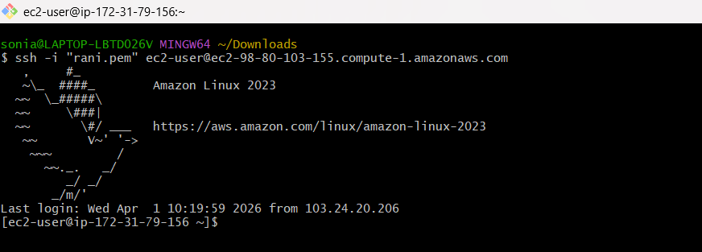
- sudo su -> root user
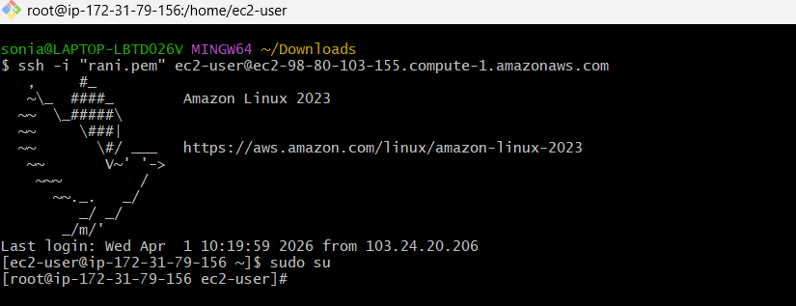
1) Install nginx and run nginx on port number 81.
- sudo yum install nginx -y
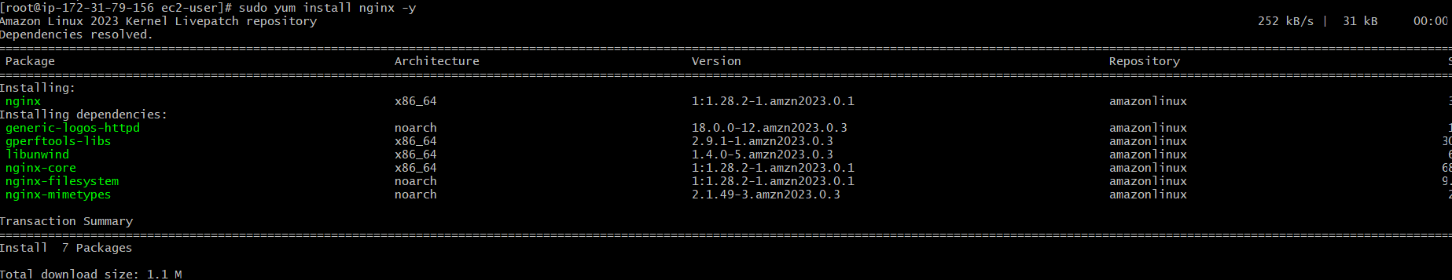
- we can see the server running or not
- sudo systemctl start nginx
- sudo systemclt status nginx
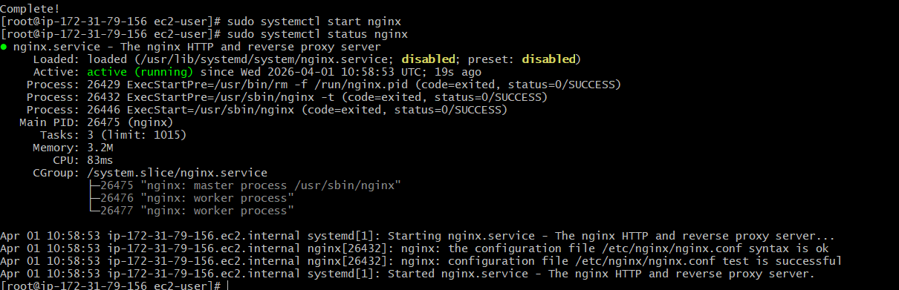
- change the port numbers given below command
- sudo nano /etc/nginx/nginx.conf

In this part to change the prot number
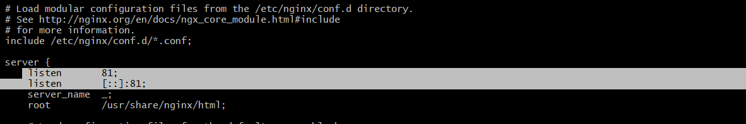
After that restart the server
- sudo systemctl restart nginx
- sudo systemctl start nginx
- sudo systemctl status nginx

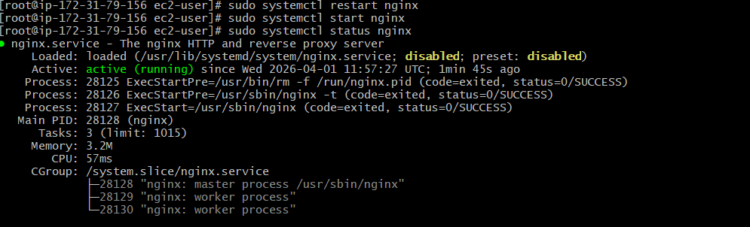
We can change the security type all traffic
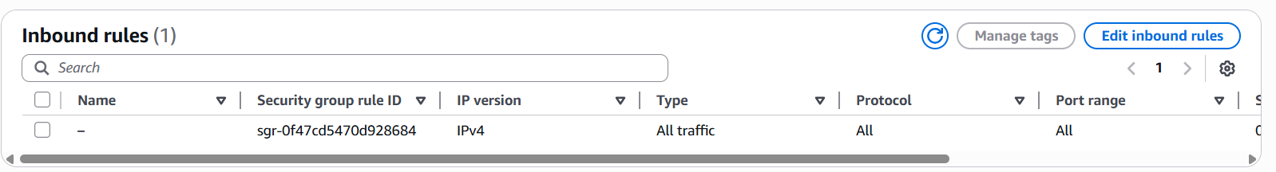

After that we can copy the ip add and open web browser paste the ip add and enter the port number 81
We can display the static website

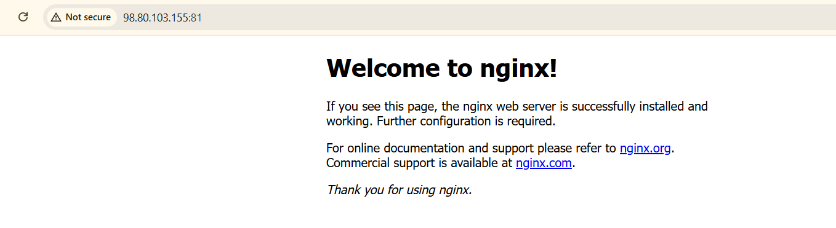

2) Deploy a sample index.html file on nginx.
- Nano index.html

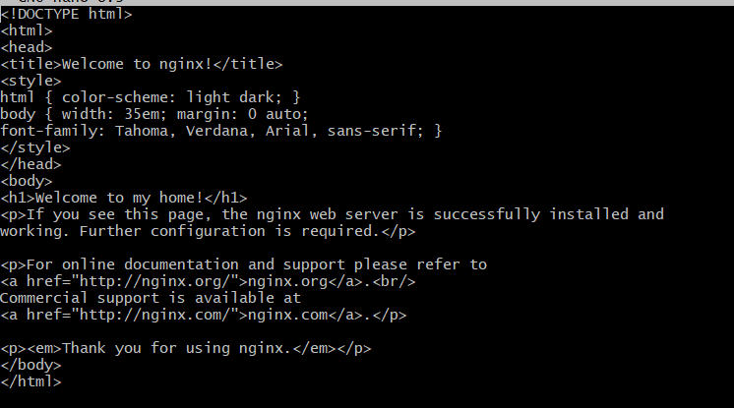
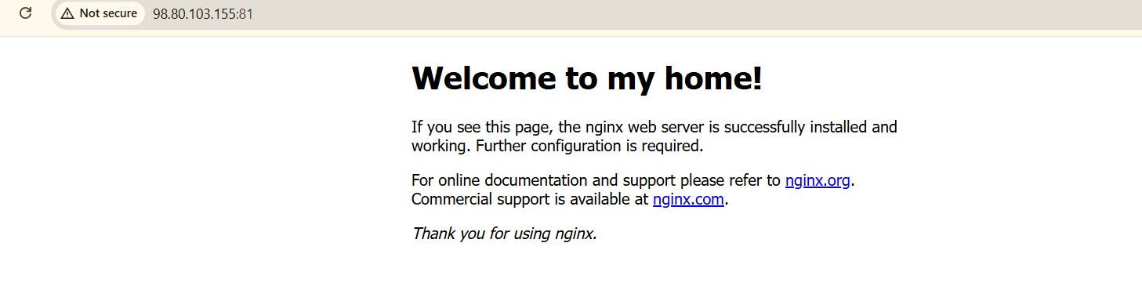

3) Install Apache and run Apache on port number 82
- Sudo yum install httpd
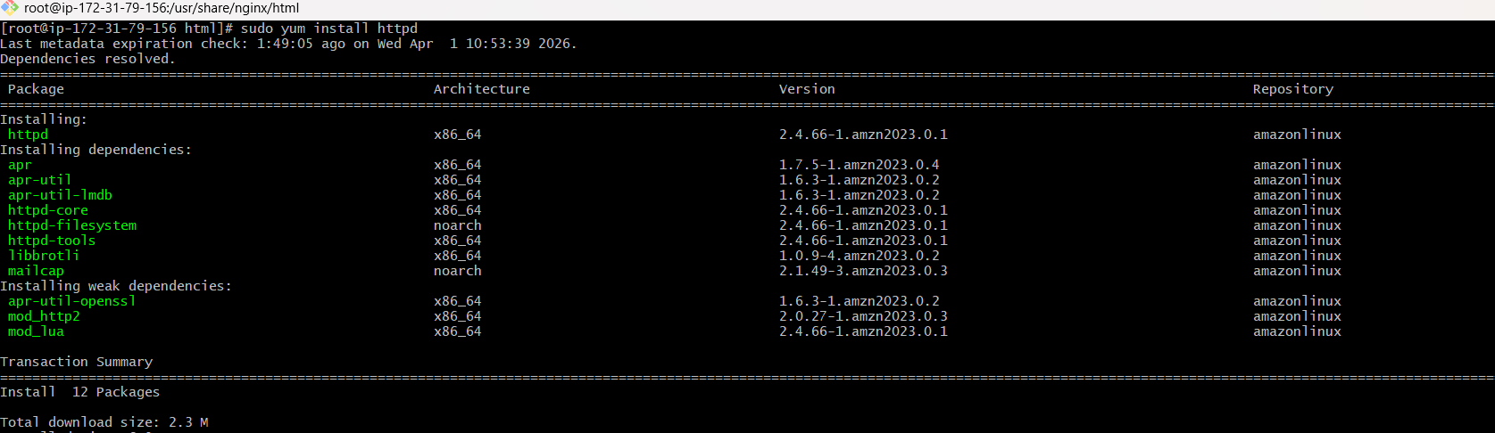
- Sudo systemctl start httpd
- Sudo systemctl status httpd
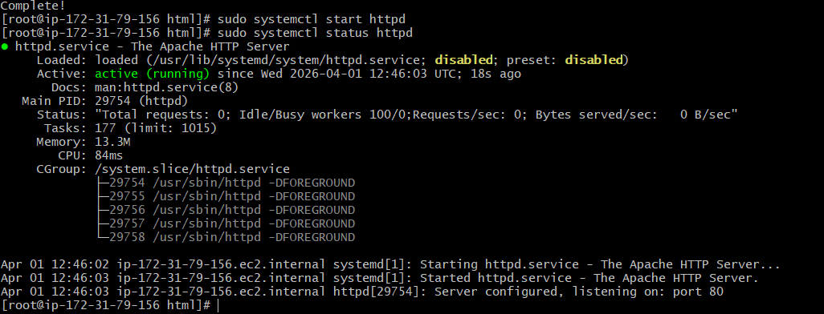
We can change the port number give that below command
We can change port number 82
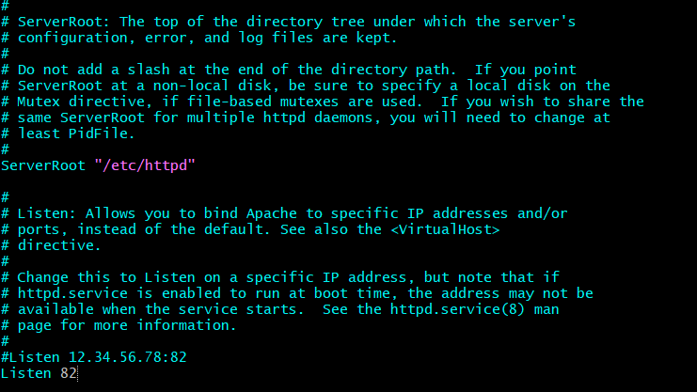
- Systemctl restart httpd
- Systemctl start httpd
- Systemctl status httpd
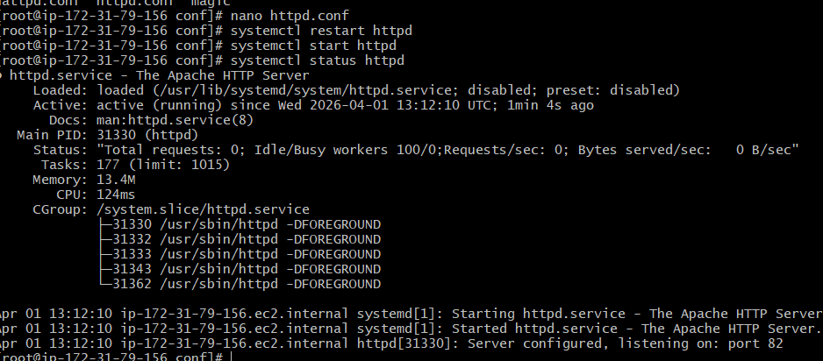
We can copy the ip add and enter we given port number 82
This is the web browser page with port numbers 82.
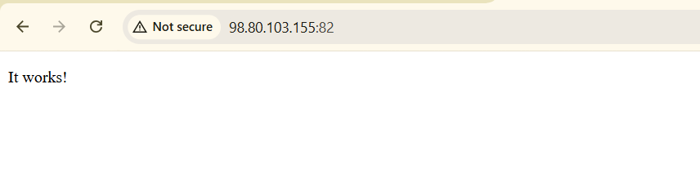
- Deploy a sample index.html file on Apache.
vi index.html
We can enter the matter inside this file and we want to edit that file we can use nano index
Sudo systemctl restart httpd
Sudo systemctl start httpd
Sudo systemctl status httpd

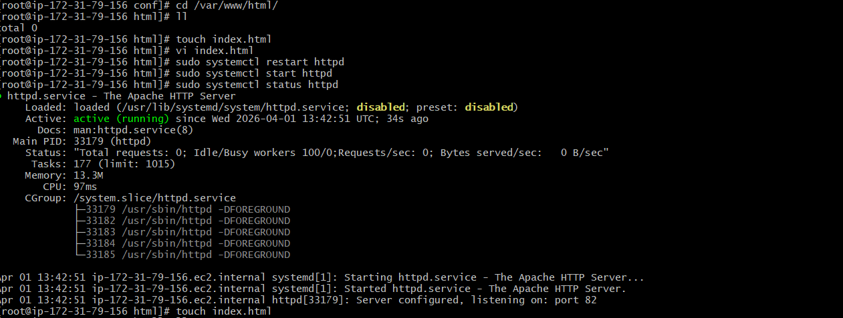
Checking in the web browser:

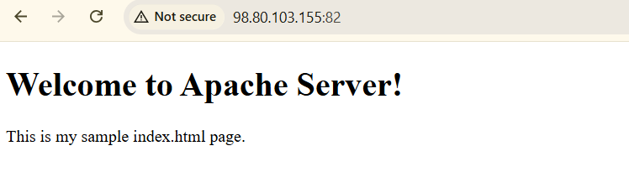
- Install Apache tomcat on port number 8082
wget ‘tomcate application link from the browser’: to install the tomcat
Java is prerequisite of apache tomcat
Install the java using yum insatll java -y
./startup.sh : to start the tomcat

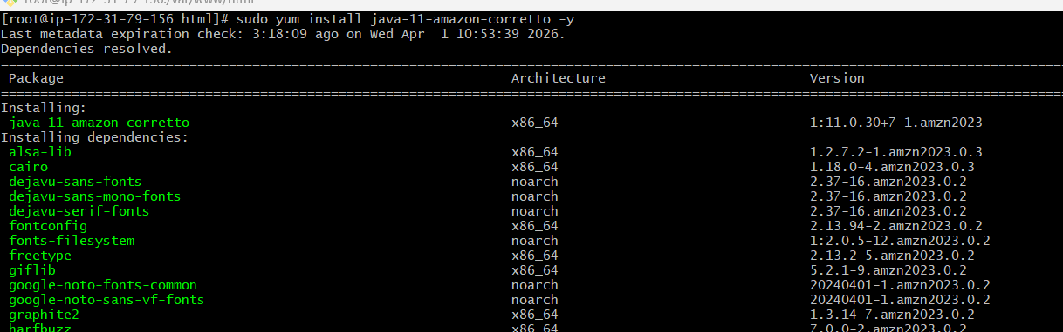
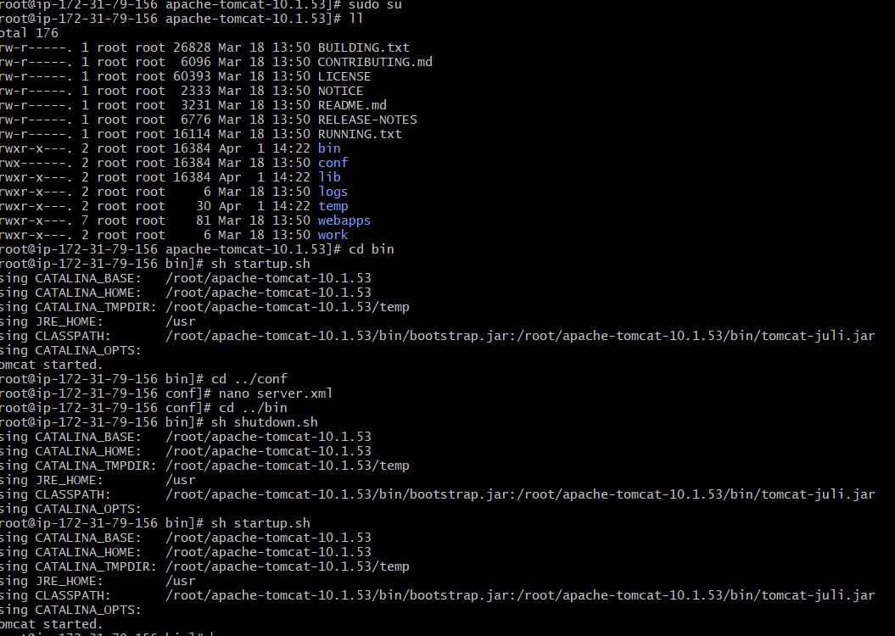
Go to the browser hit the public ip: portnumber:

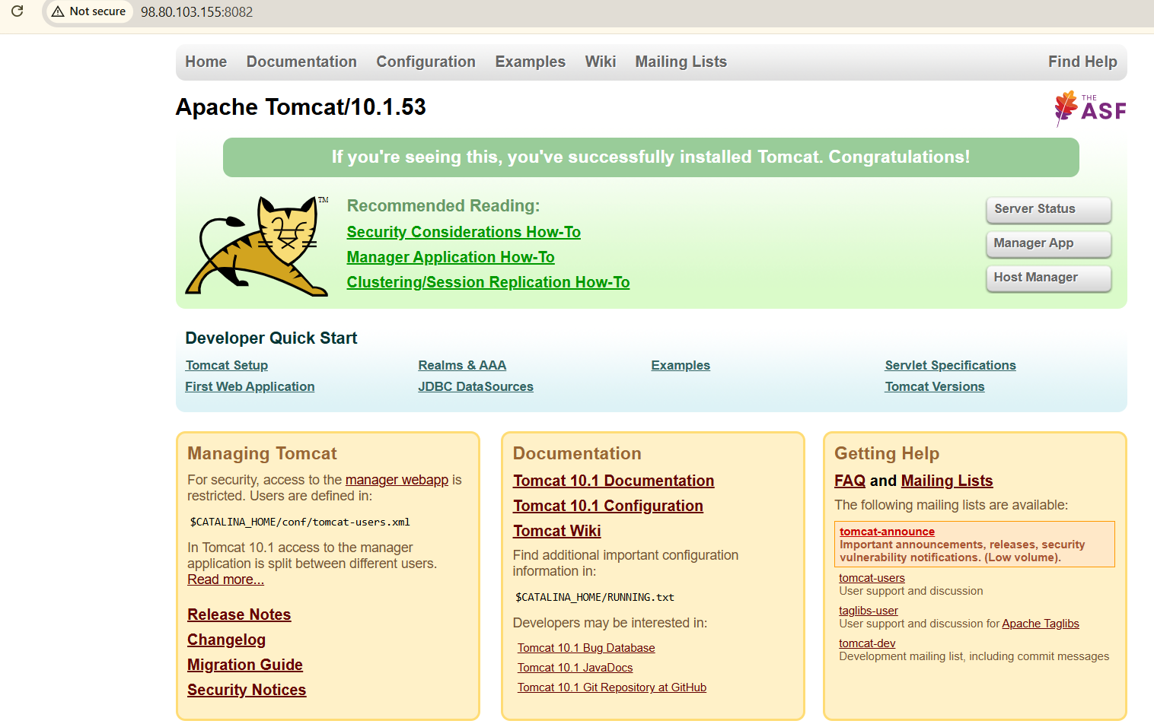
- Deploy a sample app on webapps
- We have to give ls see webapps new directory is creating it is default file .
- We have to give sample.war link to tomcat command using wget we have to see this deploy a sample app on webapps.

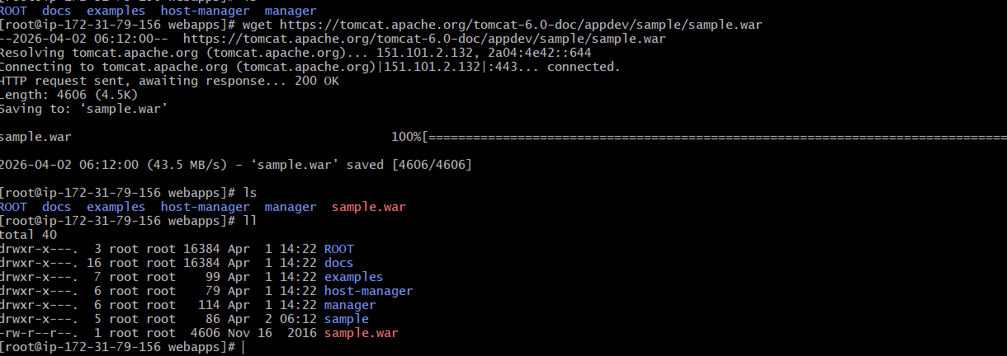
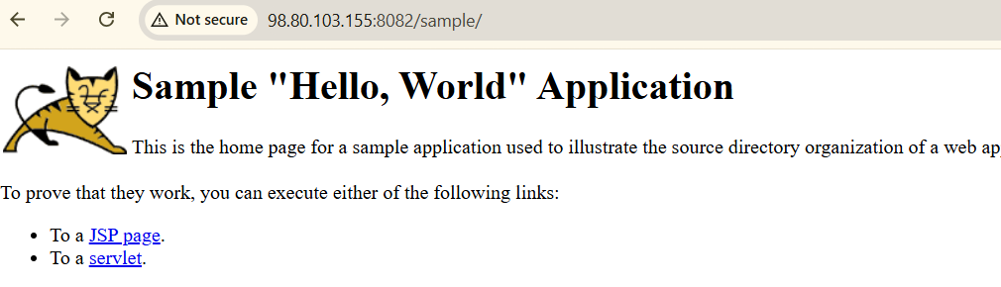
- Create a tomcat.service file for tomcat.
Use these commands to run this :
• Sudo systemctl daemon-reexec
• sudo systemctl daemon-reload
• sudo systemctl enable tomcat
• systemctl start tomcat
- systemctl status tomcat

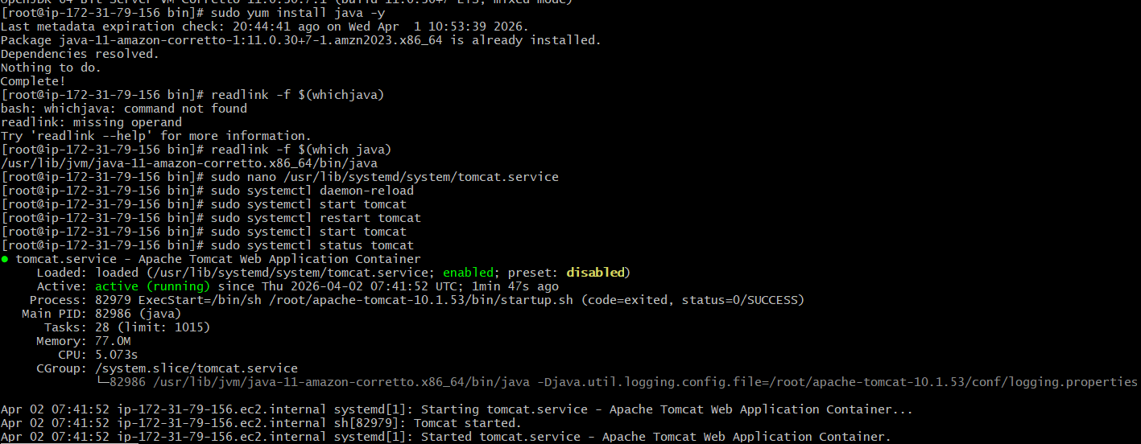

8)Configure HA Proxy server
Launch 3 ec2 instances name as server-1,server-2,ha-procy-server
Server-1 steps:
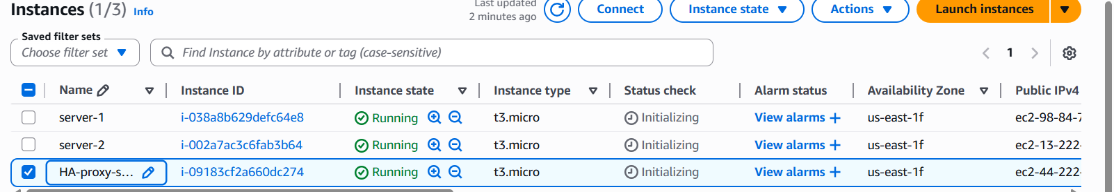
Run following command to access the server-1
- ssh -i your-key.pem ec2-user@Pubipaddress of Server-1 instance
- Sudo -I
- Yum update -y
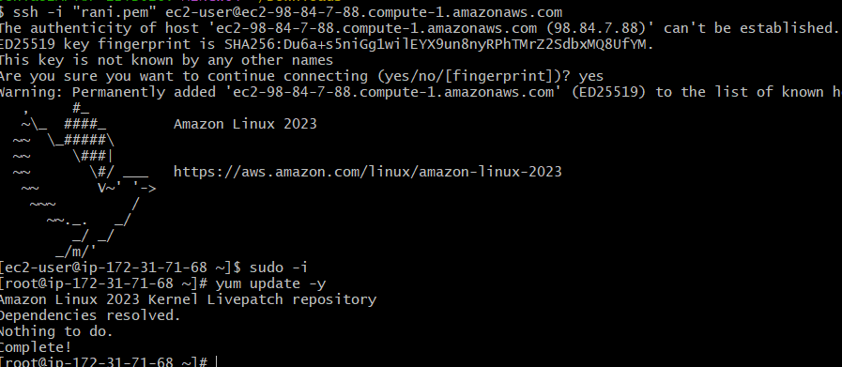
- Yum install httpd -y

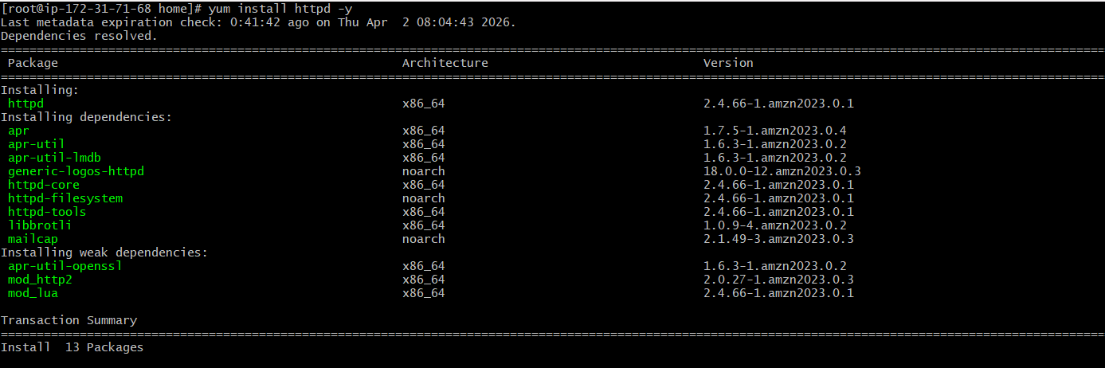
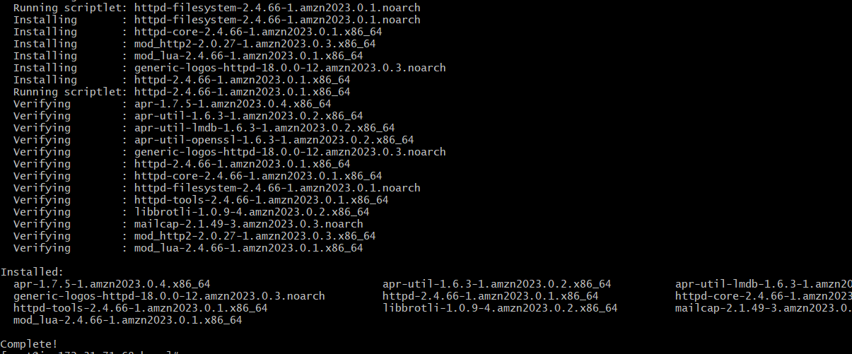
- Vi /etc/hosts
- Add HA-Proxy-Server Pubic IP Address
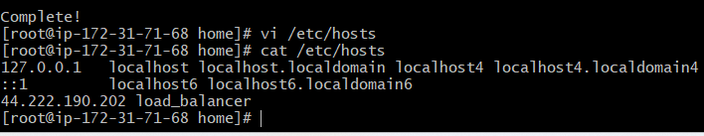
Run below command on Server-1
- ping load_balancer -c 4
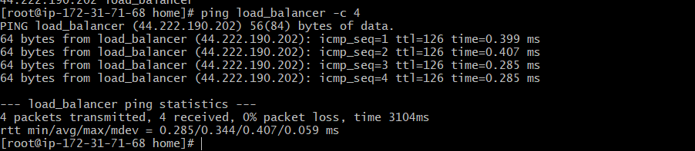
- systemctl start httpd
- systemctl status httpd

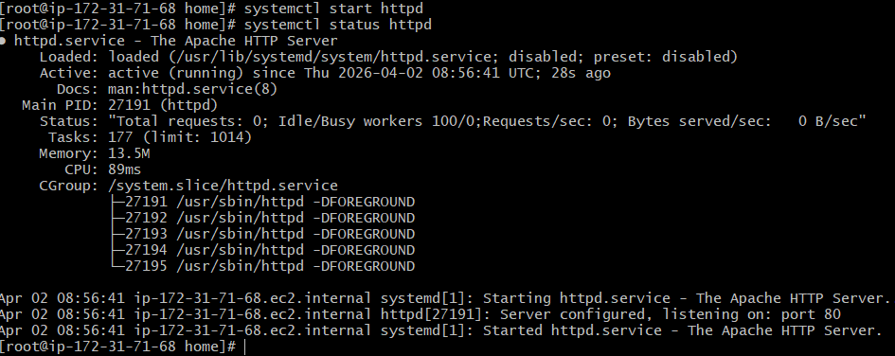
Browswer with server-1 public ip address:80 it wii work
Server-2 Steps:
Run following command to Access Server-2
- ssh -i your-key.pem ec2-user@Pubipaddress of Server-2 instance
- Sudo -i
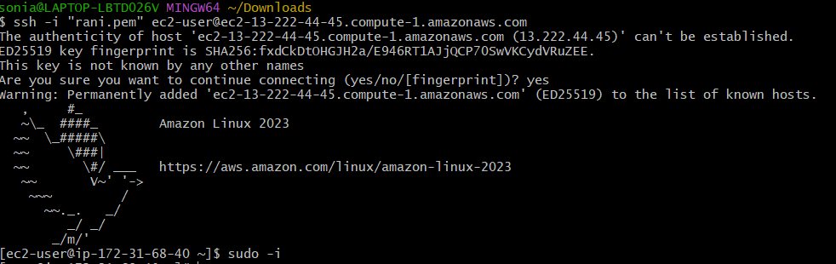
- Yum update -y
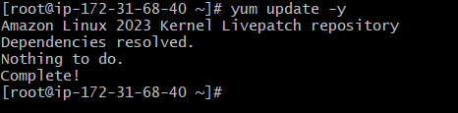

- Yum install niginx -y
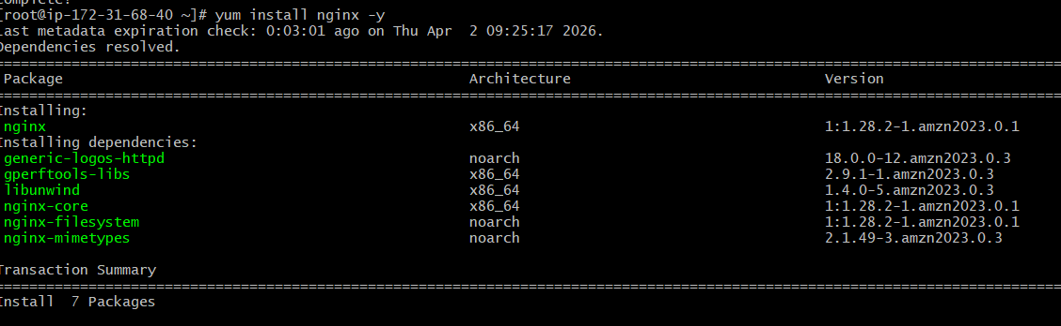
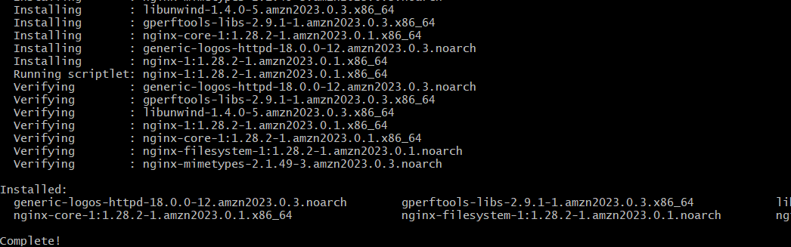

- vi /etc/hosts
- Add HA-Proxy-Server Pubic IP Address

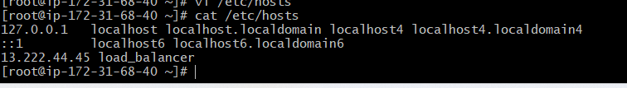
Run below command on Server-2
ping load_balancer -c 4
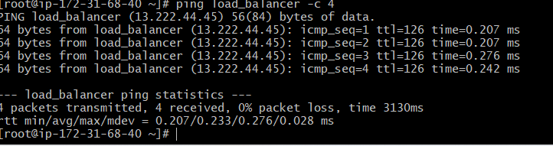
- systemctl start nginx
- systemctl status nginx
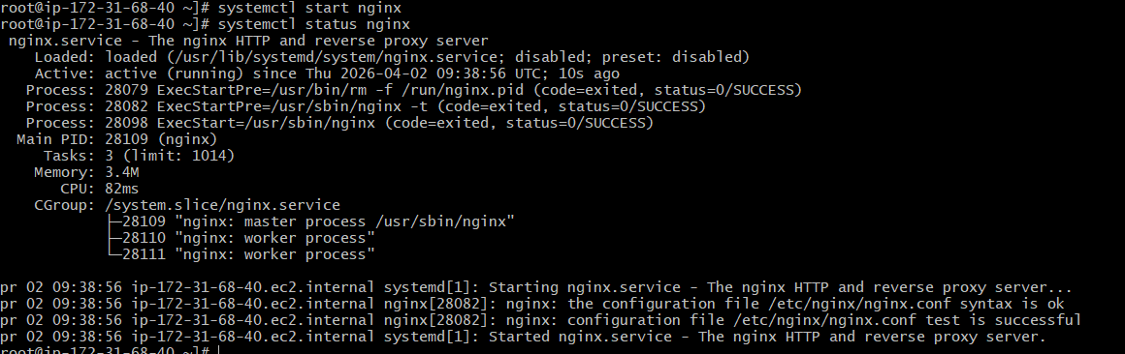
Browse with Server-2 Public IP address:80 it will work
HA-Proxy-Server Steps:
Run following command to Access HA-Proy-Server
- ssh -i "rani.pem" ec2-user@ec2-44-222-190-202.compute-1.amazonaws.com
- Sudo -I
- Yum update -y
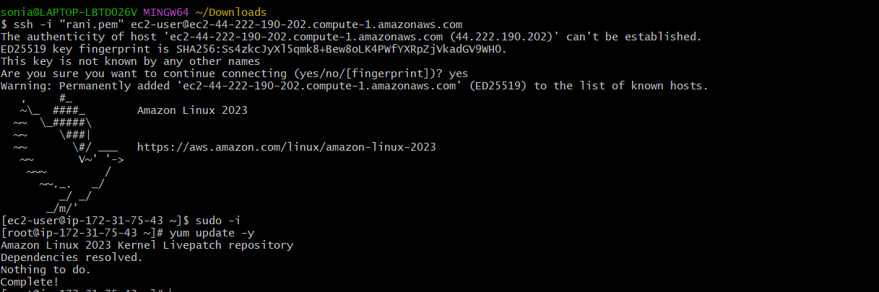

Yum install haproxy -y
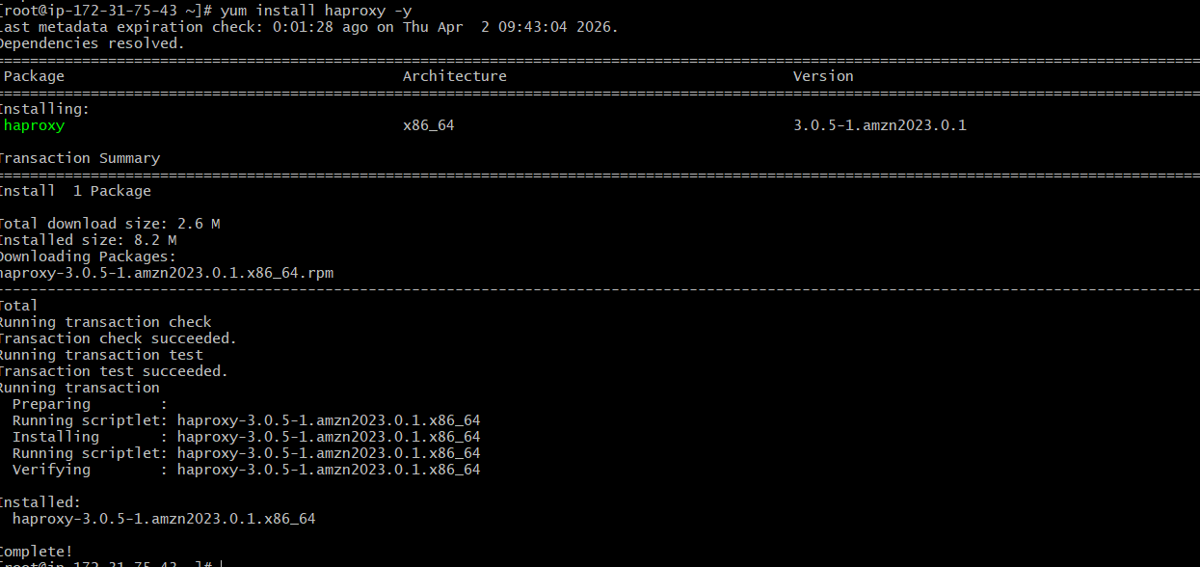
- vi /etc/hosts
Add Server-1, Server-2 Public IP’s
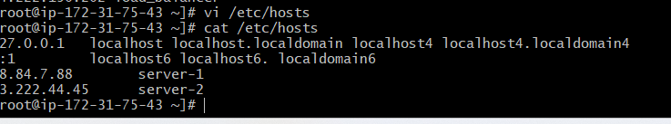
- vi /etc/haproxy/haproxy.cfg
- Add Server-1, Server-2 public IP’s
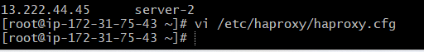
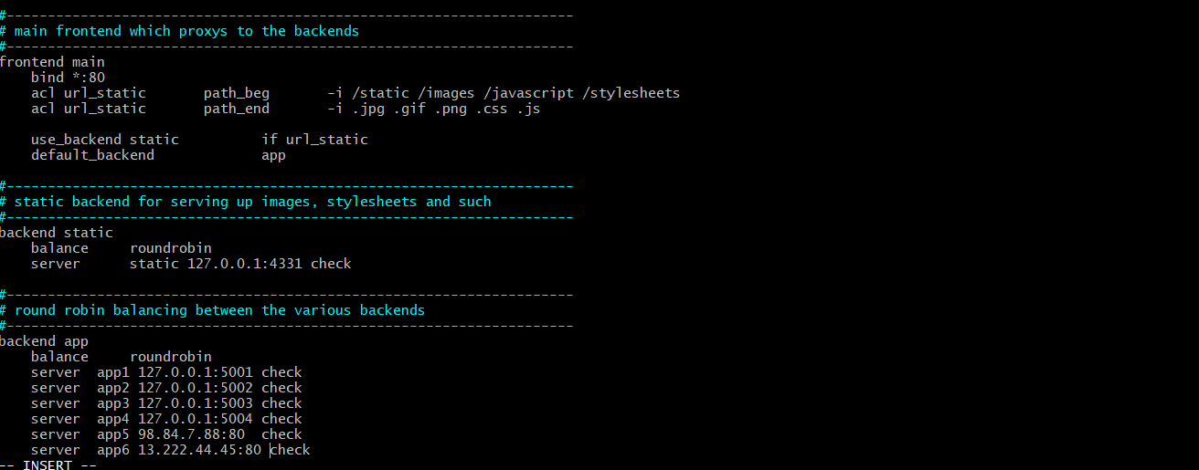
- systemctl enable haproxy
- systemctl start haproxy
- systemctl status haproxy
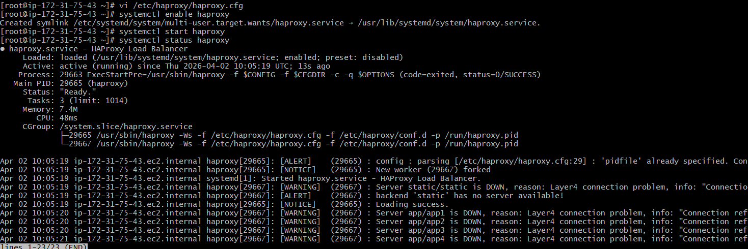
- now browse with HA-Proxy-Server PublicIP:80 it will distribute load to Server-1, Server-2

